Project No. | 32.36894 | Task No.: | 32.36894-TE.003.03
Project: | K0 | Test coordinator: | Andreas Hoffstadt
Component: | K0 NAFTA_Complete Front Seat | Representative: | Martin Engel
Customer: | Stellantis

Start (Plan): | 2026-02-26 |  |  |  | External lab possible: |  |  | Yes |  | No
Language of report: |  |  | German |  |  | English

Sample ID: | SMP-917434 / PV_K0_NAFTA_DRV_ID 030 (Qty. 1) | Sample availability: | NO
Sample Content: | 6586185_DRV, 6WM, LHD, SAB, ARMREST, LUMBAR, HEATER, FABRIC CURITIBA BITON VP NAFTA | Fixture/BIW
Additional Notes |  | Part Level

Deviations

Test Requirements of Dynamic Test / Impact With Dummy / Generic
Test Criteria
Test Regulation | Test performed according to the Stellantis test procedure B32-3210
Test Object | Test applicable on K0 complete front seat
Test Fixture | K0 front seat crash fixture for metal validation (simulating podium as rigid)  K0 foot rest  K0 B-pilar
Sled Pulse [Number] | STM file appendix 1 generic pulse for front impact (all seat rows) seat sizing generic pulse:  Rexroth => J050271  Seattle safety => J100357
Direction of Acceleration | Forward direction
Additional Information Test Setup
Description how to mount the fixture + Bpilar + foot rest on the sled (example of LH seat):
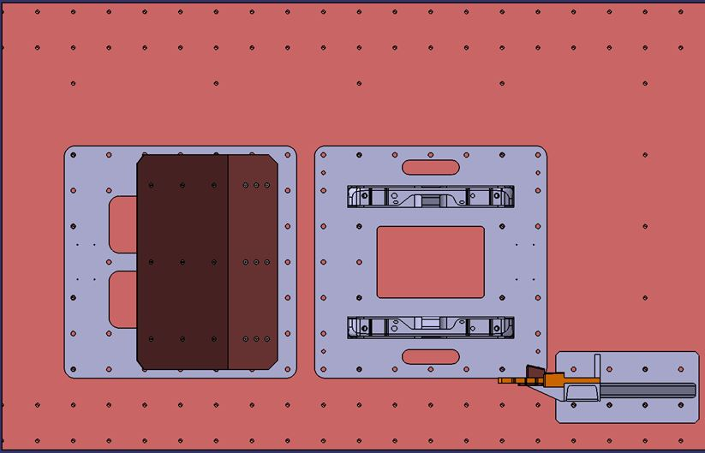
Sketch / Picture Test Setup | Method how to calculate the pelvis H-point by tracking the femur:  Initial position of the thigh model:  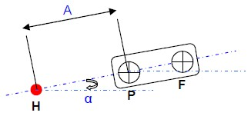  Maximum forward position of the thigh model:  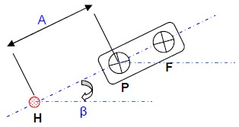  Before test:  Adjust the dummy in order to fullfill Hpoint and pelvis angle corridor.  Attach on the femur plate the targets P and F in order that Hpoint + target P + Target F are on one line  Measure the distance A between the H point and P femur pattern and angle alpha by recording with faro arm the Hpoint and target P and F coordinates  After test:  By using tracking software  Measure on the first frame of the movie the angle Alpha formed by the straight line passing through the center of two femur patterns P and F and horizontal.  Measure at the maximum advanced position of the pelvis the angle Beta formed by the straight line passing through the center of the two femur patterns P and F and horizontal.  Measuring ΔXp at advanced X position of the point P  Measuring ΔZp at advanced Z position of the point P  Calculate the coordinates of H advanced such as:  Hx= A cos α + ΔX_{P} – A cos β  Hz= A sin α + ΔZ_{P} – A sin β
Camera Setup Overview | 1 - Mid Left 90° | 2 - Mid Right 90° | 3 - Top camera | 4 - Front Left 45°
Environmental condition | 23+/-5°C
Pre Test Measurements | 1 - Measure with faro arm the buckle fixing point coordinates X / Y / Z  2 - At he buckle area, mark 15 points with interval of 10mm each on the cushion side-member and measure this points with faro arm the X / Y / Z coordinates as described in the test preparation section  3 - Measure with faro arm the X-Y-Z coordinates at the IB and OB FSC side-member nose area  4 - Measure the unlocking force at the buckle
Test Preparation | 1- Mark the belt every 100mm from the D-loop to the retractor and further  2 - Mark all the mechanisms with a white marker  3 - Fix markers like described under "Additional Information Video Analyze" and measure Y-distance to the camera  4 - At the buckle area, mark 15 points with interval of 10mm each on the cushion side-member and measure this points with faro arm  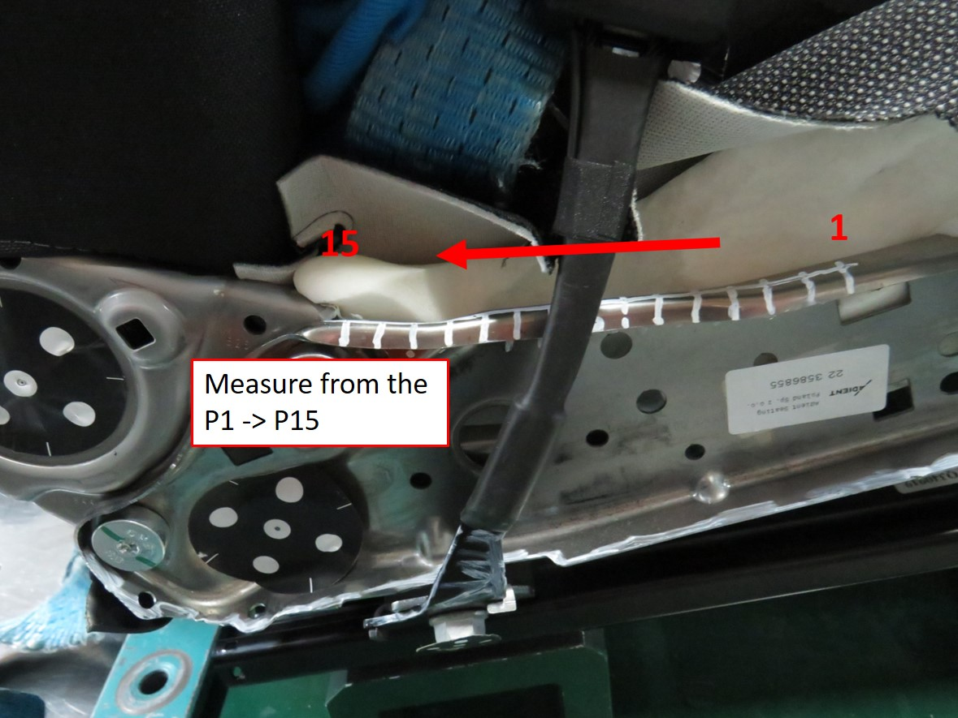
Post Test Measurements | 1 - Measure with faro arm the buckle fixing point coordinates X / Y / Z and calculate gap to pre-test  2 - At he buckle area, mark 15 points with interval of 10mm each on the cushion side-member and measure this points with faro arm the X / Y / Z coordinates as described in the test preparation section and calculate gap to pre-test  3 - Measure with faro arm the X-Y-Z coordinates at the IB and OB FSC side-member nose area and calculate gap to pre-test  4 - Measure the unlocking force at the buckle and calculate gap to pre-test  5 - Take picture of the lap belt if still in contact with the Iliac bone area for submarining rating
Video Analyze | 1 - Pelvis displacement in X and Z Video analysis (Refer to "Sketch / Picture Test Setup") + Double integration | 2 - Headrest centre line x-tracking without untrimming headrest
Additional Information Video Analyze | Add the following targets on the dummy and measure the distance to the camera : 12 targets totally to be recorded  => Cog Head IB / OB  => Shoulder IB / OB  => Knee IB / OB  => Ankle IB / OB  => H-point IB / OB  => Heel point IB / OB  Add the following targets on the seat and measure the distance to the camera : 13 Targets totally to be recorded  => Headrest IB / OB / TOP  => Headrest rod IB / OB  => Top of the back frame IB / OB as per below instruction (untrim locally to fix it on the frame) :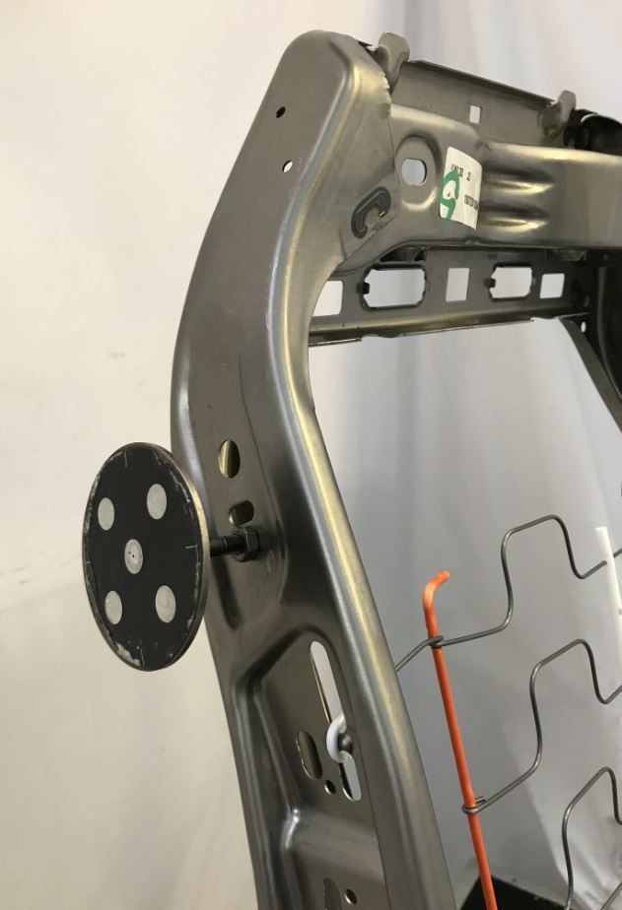  => Recliner pivot point IB / OB (remove the OB side valence if necessary)  => Cushion side-member nose area as per below description: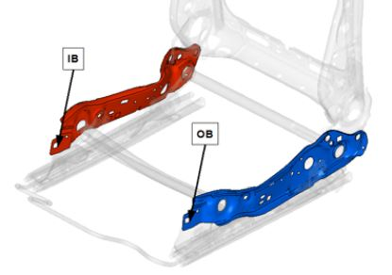  => Buckle fixation point  => Buckle

Part Criteria PV_K0_NAFTA_DRV_ID 030 6586185_DRV, 6WM, LHD, SAB, ARMREST, LUMBAR, HEATER, FABRIC CURITIBA BITON VP NAFTA
Type of Dummy | 50% HIII M
Additional Dummy Instrumentation | 1 - Lumbar spine | 2 - Ata Sensor pelvis
Dummy setup information front seat | Parameter Coord. Target Actual  H-Point [mm] X 1164.3mm+DX -13mm<Crash dummy X-Hpoint<1164.3+ DX+13mm (DX to be provided by the VE  Y +/-380  Z 654.4+DZ-19<Crash dummy Z-Hpoint<654.4+DZ + 7 (DZ to be provided by the VE)  Heel Point at the foot rest [mm] X 566.5  Y n/a  Z 275  Feet angle [deg] at heel point / 40°  Pelvis Angle [deg] / 22.5 +/- 2.5  Head Angle [deg] / 0° +/-2.5° around Y and X-axis  Head COG [mm] X no requirement defined by procedure  Z no requirement defined by procedure  Description how to adjust heel point coordinates:  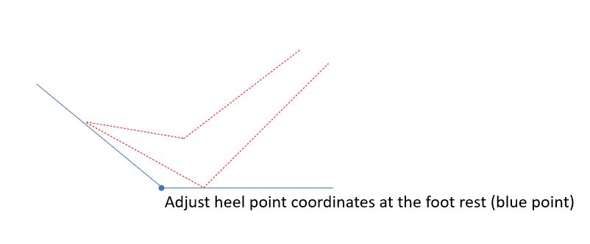  To measure and to record with faro arm the floor support intersection point and real dummy heel point
Belt System | 1 - Original belt buckle for K0 project NAFTA variant  2 - Original PLP for K0 project NAFTA variant  3 - Original belt for K0 project with 600daN NAFTA variant  Belt elongation = (Input from FEA required)
Belt Coordinates D-Loop | D-loop fixing point:  X = 1480.7mm  Y = +721.1mm  Z = 1276.3mm  Retractor fixing point:  X = 1413.9mm  Y = +752.9mm  Z = 388.7mm
Belt Coordinates lower Outboard | PLP fixing point on Bpilar:  X = 1425.2mm  Y = +700.3mm  Z = 251.7mm
Belt Force Sensor | 1 - Diagonal belt sensor => Distance to the D-ring = 200mm | 2 - Lap belt sensor outboard => Minimum distance to the outboard low fixation = 150mm
Firing Time Pretensioner [ms] | PLP = 20ms  The PLP device shall be blocked (integrated in the Bpilar design)
Firing Time Retractor [ms] | Retractor = 10ms
Additional information pretensioner | Pull in force = (input to be filled by FEA)  Pull in displacement = (input to be filled by FEA)
Track Position | 110mm forward from the fully rearward position  For locking the tracks proceed to the below steps:  1 - Fully rearward to put the screw IN  2 - Fully forward to put the screw IN  3 - Driving minimum 4 times between the end stops fully forward and fully rearward  4 - Sliding the to the test position until locking  5 - Shaking seat on tracks  6 - Checking locking pin and mark it with white marker
Cushion Height Position | n-a
Backrest Angle (describe exactly how to measure) | Backrest to be adjusted in design position => angle from recliner pivot point to headrest bezel exit centre point = 14.5°
Headrest Height Position | 1 - Adjusted to the height of the head => Z-backset closest to 0mm  2 - Adjust the headrest in X to the fully rearward position
Fastening Parts | Original Renault / Nissan screw and reducing head diameter to 17.8mm as per original screw drawing | | Torque = 35Nm for each of the 4 screws

Additional Notes:

Evaluation Criteria
Sample: SMP-917434 / PV_K0_NAFTA_DRV_ID 030 (Qty. 1) 6586185_DRV, 6WM, LHD, SAB, ARMREST, LUMBAR, HEATER, FABRIC CURITIBA BITON VP NAFTA
Description | Criterion / Value | Charac. | Unit | Num Result | Comment | Rating
Cushion flange IB side-member permanent deformation in Y-direction | < 10mm |  | mm
FSC side-member cushion nose area permanent deformation in Y-direction IB and OB sides | < 80mm |  | mm
FSC side-member cushion nose area permanent deformation in Z-direction IB and OB sides | < 80mm |  | mm
Belt buckle fixing point permanent deformation resultant vector X / Y / Z directions  Vector = (DX²+DY²+DZ²)^1/2 | < 10mm |  | mm
Pelvis dynamic X-displacement IB and OB sides | Shall be less than front seat structure front edge and with 50mm margin  Methodology for each side:  1 - determine initial DX distance between initial Hpoint and seat frame cushion nose area (both recorded with faro arm)  2 - Determine max dynamic Pelvis H-point outboard side = B  3 - Rating shall be : DX - B -50 > 0mm (same logic for IB side) |  | mm
Integrity of the seat | Seat adjustment and locking systems (headrest, backrest and track) maintain original set position  No portion of seat shall separate from integrated seat frame assembly  No aggressive part shall appear (sharp or cutting edge) which can be in contact with the dummy  The seat shall remain attached at each fixation point  No crack, no rupture, no breakage, no ejection, no separation of the seat or seat parts  No unlocking, adjusting or disengagement of any mechanism during the test  No separation or breakage of any part in such a way that tips or sharp edges could increase the risk of injury for the occupants
Pelvis resultant acceleration (3ms) | Spec < 80G |  | g
Max dynamic pelvis X-displacement average of IB and OB sides | < 160mm for NAFTA configuration / double pretensioner |  | mm
Max dynamic pelvis Z-displacement downwards average of IB and OB sides | < 40mm |  | mm
Submarining behaviour | No submarining shall occur (by analysis positioning of the lap belt post test and checking lap belt force graph)
Dynamic X-displacement of the headrest using TOP target | < 380mm |  | mm
Variation pre-post test unlocking forces at the buckle | Only for information |  | N

